OFFICE 365 TRAINING
THURSDAY 23rd MAY or
THURSDAY 20th JUNE
10.00am – 12.00pm
WI House, 17 Couch Lane
Devizes SN10 1EB
What is Office 365 and what can it do for your WI?
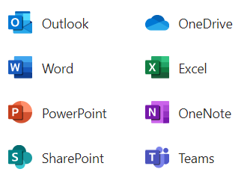 |  |  | We are offering WI Officers training on how to use the free online package provided by WFWI.  Whether you are new to this package or have used it before, come along and learn what it can offer your WI.  You will need to bring a laptop or tablet with you.  There is no charge for this training.
CLOSING DATE:
Thursday 16th May / Thursday 13th June
 | ENQUIRIES TO: |  |  | Tel: 01225 782092
 | Lesley Holdway |  |  | Email: lesleyholdway@wiltshirewi.org.uk
Email confirmation will be sent closer to event date.

