 | WILTSHIRE
  Office 365 Training |  | Monday 11th August  10.00am – 12.00pm  or  Tuesday 9th Sept  12.00pm – 2.00pm
WI House
17 Couch Lane
Devizes SN10 1EB
We are offering WI Officers training on how to use the free online package provided by WFWI.  Whether you are new to this package or have used it before, come along and learn what it can offer your WI.  You will need to bring a laptop or tablet with you.  There is no charge for this training.  TryBooking: https://www.trybooking.com/uk/EVNV |  | Closing Date:  Aug Session: Mon 4th  Sept Session: Tues 2nd
 |  | 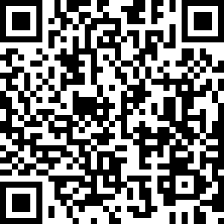
The following information must be sent to admin@wiltshirewi.org.uk when booking:  WI, Attendee Name, Date attending,  Contact email and telephone number |  |  | Wiltshire Federation of WIs  WI House, 17 Couch Lane  Devizes SN10 1EB  01380 739340  Charity No: 1197142

