CRAFT COMPETITION 2024
Create a Wall Hanging / Wall Art in Any Medium
Create a wall hanging in a medium of your choice. It could be a picture, a clock, an inspirational quote, a sculpture, etc. Please ensure your final piece is no bigger than A3 (297mm x 420mm / 29.7cm x 42cm / 11.7” x 16.5”). |  |  |  |  | 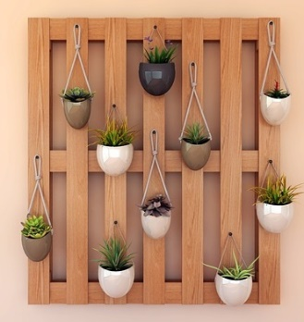
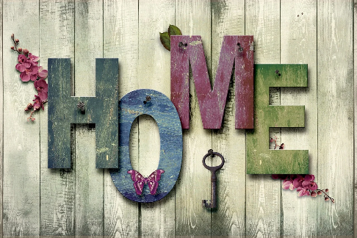 |  |  | Please send entries to:  WI House, 17 Couch Lane, Devizes SN10 1EB together with an explanation of what materials you have used.  All entries will be displayed at the ACM in October and on www.wiltshirewi.org.uk for members to view online after the closing date.
Alternatively, you can deliver in person to WI House (please call in advance to ensure the office is open 01380 739340).  Entries can be collected at the end of the day at the ACM in October or from WI House. |  |  |  |  |  | 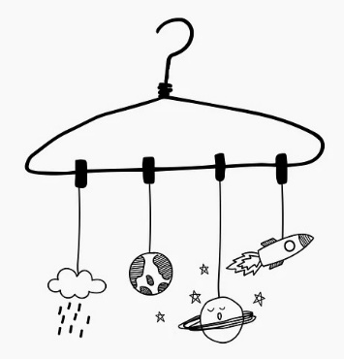
 | ENTRY FEE: £2.00
CLOSING DATE: Monday 9th September 2024
ENQUIRIES TO: |  | Shauna Bodman |  | Email: shaunabodman43@gmail.com

