WILTSHIRE FEDERATION OF WIs Charity Number: 1197142
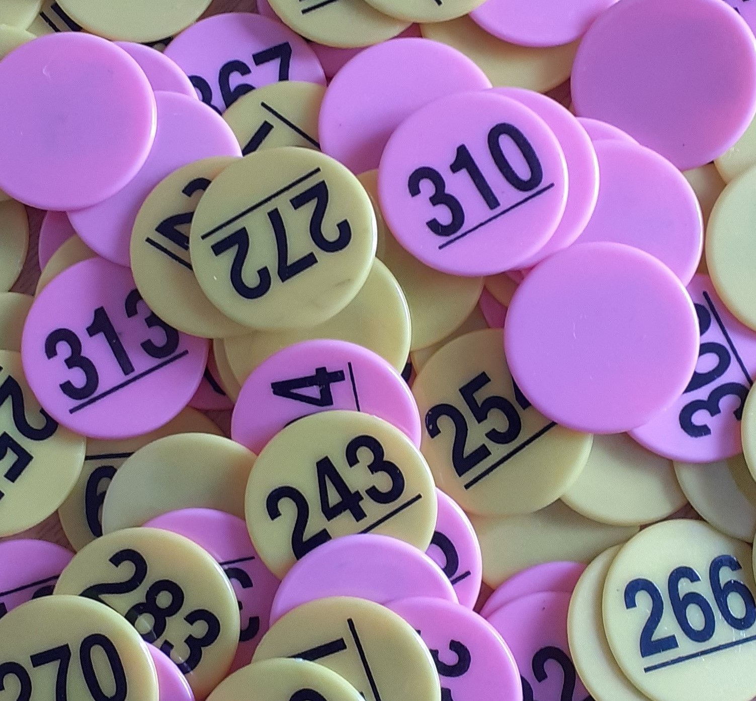
“50/50” CLUB 2023/2024

£6.00 per ticket for inclusion in 12 draws

You could win £25.00 each month

Main prizes drawn at October WFWI ACM.

Closing date for first draw: 1st November 2023

PTO for rules

WILTSHIRE FEDERATION OF WIs – 50/50 CLUB 2023/2024
Name: |  |  |  |  | WI:
Tel No: |  |  | Email:
My account name:
My sort code: |  |  |  |  | My Account No:
Address:
I wish to become a member of the 50/50 Club 2023/2024 and agree to abide by the Club rules. Closing date for first draw, 1st November 2023 and the 1st of the month for each subsequent draw.
No. of tickets required:
I enclose my subscription of 50p per month per ticket.
BACS Payments: Account Name: Wiltshire Federation of WIs Sort Code: 30 96 26 Account No: 79519268
Ref: your name5050
Cheques should be made payable to Wiltshire Federation of WIs
Please send this form to Wiltshire Federation of WIs, WI House, 17 Couch Lane, Devizes SN10 1EB together with a STAMPED ADDRESSED ENVELOPE if you require your ticket to be sent to you.
Enquiries to: Stephanie Pawling on 01380 739340 or Email fedsec@wiltshirewi.org.uk

“50/50” CLUB RULES
- The name of the Club shall be the ‘WFWI 50/50 Club’. It shall be organised as a function of the Board of Trustees who will appoint an event organiser for the Club.
- The Club is open to individuals only, and any club member shall be entitled to inspect the Club accounts upon reasonable notice being given.
- Only cash, personal cheques or BACS can be accepted as payment to join the Club. No WI Cheques can be accepted.
- The subscription of the club shall be 50p per month. This shall be paid in a lump sum to cover the period from the month of joining up to and including the October 2024 draw.
e.g. If you join before 1st November – Then you should pay £6.00
If you join after 1st January but before 1st February then you should pay £4.50 etc.
- Each subscriber will be given a ticket bearing their unique number. Club members may purchase more than one ticket.
- There shall be at least 140 members and the total prize money shall be equal to 50% of the total subscriptions.
- All tickets will be entered into a monthly draw for a prize of £25. The draw to take place on or about the middle of the month at the Board of Trustees meeting, by an independent person (someone who is not a ticket holder).
- A special draw for prizes totalling a minimum of £150 will be held at the Annual Council Meeting in 2024.
- WFWI would prefer prizes to be paid by BACS, please give your bank details on the application form. Cheques can be sent if preferred. A congratulatory email will be sent to the winner after the monthly draw has taken place if an email is provided.
- The net profit shall be paid into the Federation general account annually. Any balance remaining on the winding up of the Club shall be paid to the Federation general fund.
- The decision of the Board of Trustees shall be final in any matter.

