CREATIVE BEAD MAKING WORKSHOP
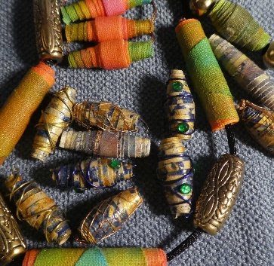 | Tuesday 30th April 2024  10.00am – 1.00pm  or  1.30pm – 4.30pm
Fabric or paper beads are a fun and simple project. You can choose the colour, shape, design, size, etc. Just let your imagination run wild!  This workshop introduces you to the basic skills and will you show how to start off your bead making journey. All materials will be provided. |  |  |  |  |  | 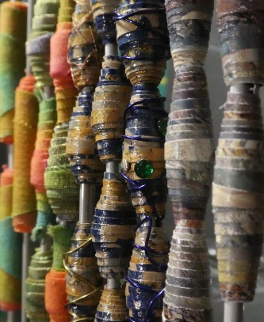
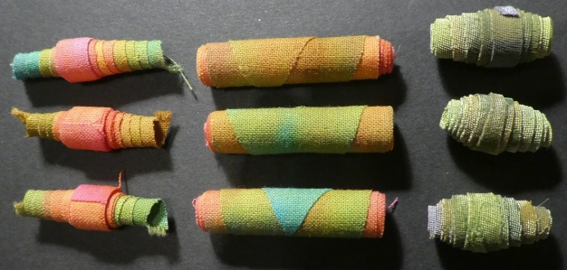 |  |  | WI House  17 Couch Lane  Devizes SN10 1EB |  | 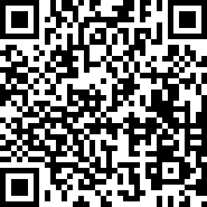
TICKET PRICE: £18.00
(includes tea/coffee/biscuits)
Non-members are also welcome.
CLOSING DATE: Tuesday 16th April 2024 (Unless fully booked)
ENQUIRIES TO: |  | Louise Hall |  | Tel: 01722 326549
(no ticket sales) |  |  |  | Email: louisehall@wiltshirewi.org.uk
Cheques will be banked once minimum numbers are reached. If a refund is due for any reason it will be sent accordingly.

