2nd NEW SPEAKERS’
DAY 2024

Wednesday 12th June 2024
Market Lavington Community Hall

St. Mary’s Road, Market Lavington SN10 4DG

11.00am until 3.00pm (Doors open at 10.15am)

This is an opportunity to attend and vote on behalf of all Wiltshire WIs for applicants to become authorised WI speakers for Wiltshire. It is permissible for WIs to pay for the Programme Secretary to attend. There is no restriction on the amount of additional tickets WI members can purchase.
TICKET PRICE: £8.00
Tea or coffee will be provided on arrival, and available to purchase
at lunch time. Cake will also be available to purchase at lunch time.
Lunch: Savoury Filo Pastry with Roasted Vegetable Salad & Cake
Orders for lunch MUST be paid for in advance at £8.00 per person. You may still bring your own packed lunch.
Closing Date: Wednesday 29th May 2024  (Unless fully booked) |  |  |  | 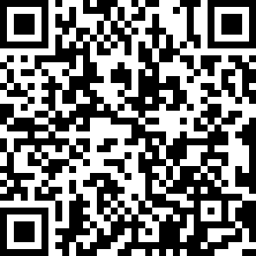
ENQUIRIES TO: | Bren Hosking |  | Tel: 07511 929020
(no ticket sales) |  |  | Email: eventschair@wiltshirewi.org.uk
Confirmation of booking will be emailed after closing date. No tickets will be issued. If a refund is due for any reason it will be sent accordingly.

