DAD’S ARMY – THE NATION’S
FAVOURITE COMEDY
with Charles Garland
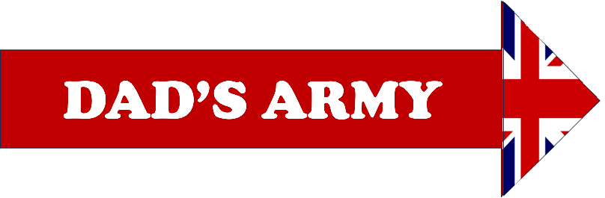 |  |  |  | TUESDAY 7TH MAY 2024  2.00PM – 4.30PM  (doors open 1.00pm)
Charles Garland was a BBC producer who worked on all 80 episodes of the Dad’s Army TV show. Dad’s Army is perhaps the most iconic of sitcoms made in the 1960s and 70s. When the series was first commissioned, some at the BBC were concerned that it was too soon to be mocking events in WWII. However, the first season was extremely successful, and Dad’s Army lasted longer than WWII!
Afternoon tea will be served after the speaker.
Southwick Village Hall
Frome Road
Southwick BA14 9QG
TICKET PRICE: £25.00 - Non-members welcome
(Dietary requirements must be advised at time of booking)
CLOSING DATE: Tuesday 9th April 2024 (Unless fully booked)
ENQUIRIES TO: | Bren Hosking |  | Tel: 07511 929020
(no ticket sales) |  |  | Email: eventschair@wiltshirewi.org.uk
Cheques will be banked once minimum numbers are reached. If a refund is due for any reason it will be sent accordingly.

