
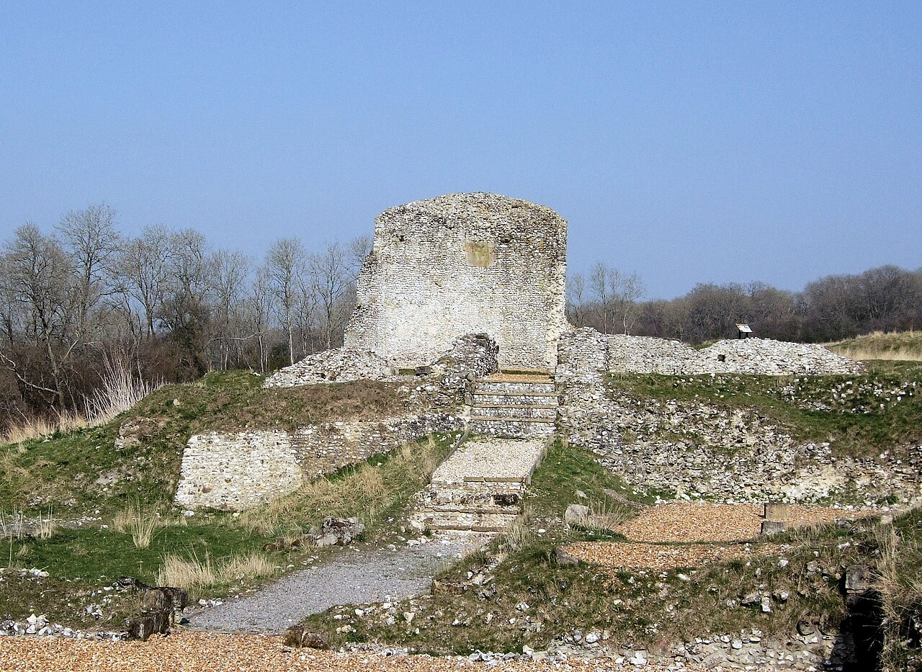  By Jim Linwood - originally posted to Flickr as The Ruins Of Clarendon Palace, Wiltshire.Uploaded using F2ComButton, CC BY 2.0, https://commons.wikimedia.org/w/index.php?curid=6447114 | Monday 15th September  10.30am – 1.00pm
£5.00 per person
Non-members welcome
Closing Date:
Thurs 11th Sept
*** New Date ***  Walking in Wiltshire  This walk is approx. 5 miles and will take about two hours. Starting from Pitton Village Hall, opposite The Silver Plough Village Pub, the route is circular and encompasses the Clarendon Palace ruins. Well behaved dogs on leads are welcome.  With permission from the landlords, parking is available in the pub car park.  TryBooking: https://www.trybooking.com/uk/EXKX |  | Meet at Village Hall SP5 1EB by 10.15am
 |  | 
The following information must be sent to admin@wiltshirewi.org.uk when paying by BACs or cheque:  WI, Attendee Name, Date attending,  Contact email and telephone number  When booking via BACs please use ref: WW0725 |  |  | Wiltshire Federation of WIs  WI House, 17 Couch Lane  Devizes SN10 1EB  Charity No: 1197142  Cheques payable to Wiltshire Federation if WIs and posted to WI House
Refunds will only be given if the Federation cancels or if you cancel before the closing date

