 |  | WINDSOR CASTLE COACH TRIP
 |  | Thursday 8th May 2025
An opportunity to spend a day exploring the late Queen’s favourite castle and discover the history of William the Conqueror’s fortress. With so much to see and do what will you choose? View the collections of paintings; meet Henry VIII (through his armour); greet the guards; visit St. George’s Chapel; explore the grounds; be overawed by stunning rooms? It really is up to you. With over 900 years to explore you may wonder if one day is enough. |  |  |  | 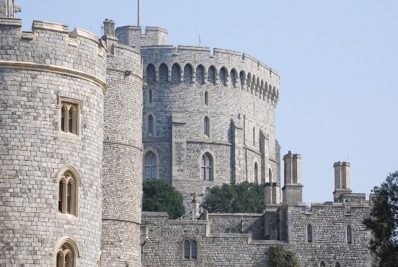
Coach pick-up points:  CHIPPENHAM (Morrisons Supermarket) 7.00am  WROUGHTON (Ellendune Centre) 7.30am  DEVIZES (Station Road Car Park) 8.00am  AMESBURY (Countess Services) 8.30am |  |  |  | 
TICKET PRICE: £55.00
Non-members welcome
CLOSING DATE: Thursday 3rd April 2025 (Unless fully booked)
ENQUIRIES TO: | WI House |  | Tel: 01380 739340
 |  |  | Email: fedsec@wiltshirewi.org.uk
Cheques will be banked once minimum numbers are reached. If a refund is due for any reason it will be sent accordingly.

