OFFICERS’ TRAINING 2024
(SECRETARIES & PRESIDENTS)
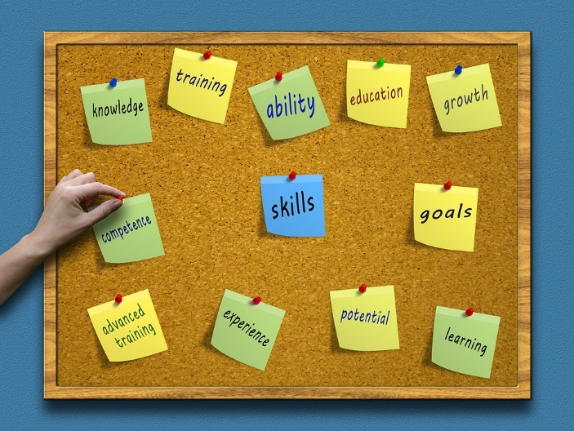 | Tuesday 18th June  Glebe Hall, Winterbourne Earls  Salisbury SP4 6HA  1.00pm – 3.00pm  Wednesday 26th June  Greatfield & Greenhill Village Hall  Hook, Royal Wootton Bassett  SN4 8EA  7.00pm – 9.00pm
£5.00 per person – your WI can pay for you to attend.
Closing date for both venues: Monday 10th June 2024
Please contact Lesley Holdway with any queries lesleyholdway@wiltshirewi.org.uk

