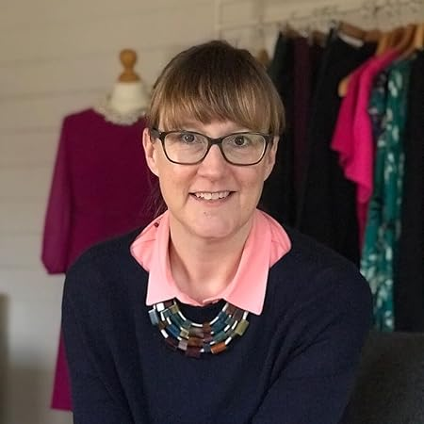 |  | FAST FASHION with Victoria Lochhead
Wednesday 15th May 2024
7.00pm – 9.00pm
In the UK we have an estimated £30 billion worth of unworn clothes hanging in our wardrobes.  We buy more clothing per person than any country in Europe.  Around 300,000 tonnes of clothing are binned every year, going to landfill or incinerators.  Victoria has a passion for finding beautiful clothes from second hand shops and jumble sales and is a firm believer that once you know the rules of what suits you best you really can shop anywhere. |  |  |  |  | 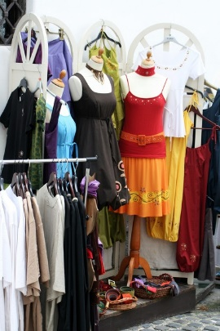
Victoria also runs an online dress agency where clients can sell their unwanted items and shop for secondhand clothing.
Great Bedwyn Village Hall
Frog Lane, Great Bedwyn,
Marlborough SN8 3PD
TICKET PRICE: £15.00 includes light refreshments
Non-members are also welcome
CLOSING DATE: Wednesday 17th April 2024 (Unless fully booked)
ENQUIRIES TO: | Corinna Mazzotta |  | Tel: 07899 937891
(no ticket sales) |  |  | Email: corinnamazzotta@wiltshirewi.org.uk
Cheques will be banked once minimum numbers are reached. If a refund is due for any reason it will be sent accordingly.

