2024 NOT IN MY NAME COMPETITION
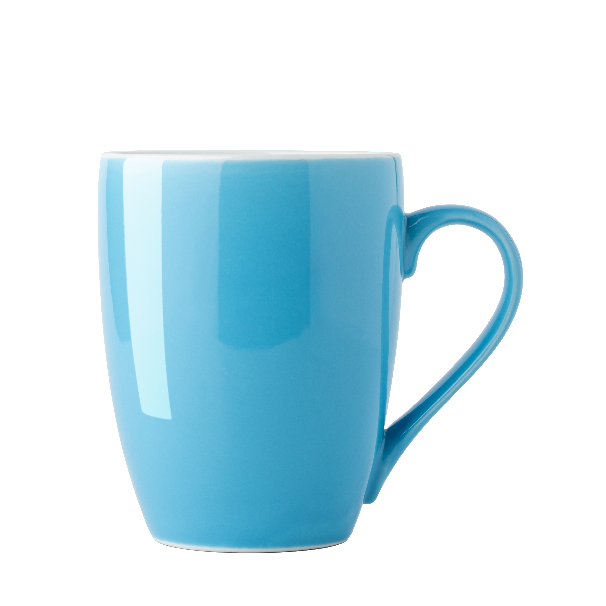
‘Design a Mug’
depicting the Not in my Name campaign to end Violence Against Women

A design created by hand (any medium) or digitally will be accepted.
Design to be presented on a mug or mug format (in original or digital format).

Judging criteria
- Creativity and originality of the design
- Mastery of chosen medium
- Interpretation and clarity of the theme
- Suitability of the design for a mug

Closing date: Monday, 4 November 2024

Submission of Entries
By post: NFWI-Wales, Suite 66, 33 Cathedral Road, Cardiff CF11 9HB
Submissions should include the following information:-
Name and contact details of entrant; name of WI; name of Federation
This competition is open to members across Wales, England and the Islands.

2024 NOT IN MY NAME COMPETITION
Competition winners
A certificate will be awarded to the winner and two runners-up.
The winner will also receive a gift card to the value of £20.

Campaign Background
NFWI-Wales and Joyce Watson MS established the Not in my Name Campaign in 2012 to raise awareness that Violence Against Women (VAW) should never be accepted, ignored or excused. By engaging WI members in recruiting male ambassadors from their local community, it aims to challenge the attitudes and behaviours of a minority of men who use or condone VAW.
Not in my Name is focused around the 16 Days of Activism Against Gender-Based Violence from 25 November (White Ribbon Day and the International Day for the Elimination of VAW) to 10 December (Human Rights Day).
The white ribbon is a symbol of men’s opposition to VAW. Wearing a white ribbon is a promise to ‘never use, excuse or remain silent about men’s violence against women’.
Find out more:-
https://mywi.thewi.org.uk/wales/nfwi-wales-campaigns-and-projects/not-in-my-name
https://www.whiteribbon.org.uk

Further information
NFWI-Wales
Tel: 029 2022 1712
E-mail: walesoffice@nfwi-wales.org.uk www.thewi.org.uk/wales

