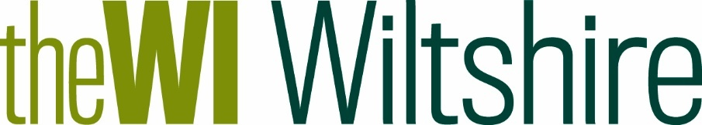
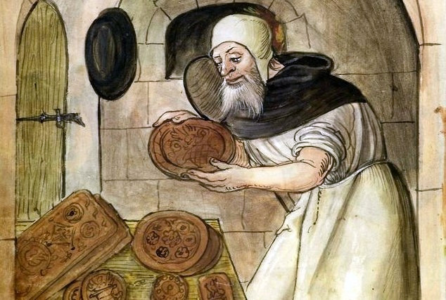  The History of Tudor Gingerbread | Wednesday 29th October  2.00pm – 4.00pm  Kington Langley Village Hall, Church Road SN15 5NJ
£15.00 per person
Includes tea/coffee
Non-members welcome
Think you know gingerbread? Think again!  Back in Tudor times, gingerbread was a whole different treat—rich with exotic spices, pressed into elaborate moulds, and even believed to help with digestion.  Step into the world of Queen Elizabeth I’s court as we explore where the Tudor recipe came from.  Join us for a lively talk and a demonstration where we’ll show you how to bake the Tudor way—no time machine required!  TryBooking: https://www.trybooking.com/uk/FCRL | Closing Date: Tuesday 21st October
 | 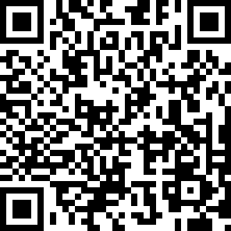
The following details must be emailed/posted to admin@wiltshirewi.org.uk (unless using TryBooking):  WI Name, Contact Name & email address  Number of tickets Required  Attendee(s) Names  Total amount due  BACs Payments: (use ref: WI & GINGER)  Refunds will only be given if the Federation cancels or if you cancel before the closing date |  | BACs payments:  Wiltshire Federation of WIs  Sort Code: 30 96 26  Account No: 79519268  Cheques payable to: Wiltshire Federation of WIs
and posted to:
WI House
17 Couch Lane
Devizes SN10 1EB
Charity No: 1197142
01380 739340

