BLACKWORK EMBROIDERY WORKSHOP
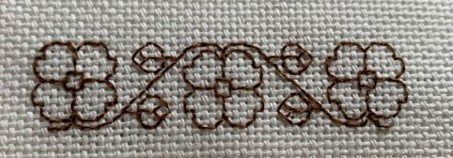 |  |  | Friday 19th or  Saturday 20th July  10.00am – 3.00pm
Blackwork has a long history and comes in a variety of colours and styles. This workshop will try out some basic techniques. Traditionally worked on a fine even weave linen, we will use an easier weave – but do please bring a magnifier if you need one. Fabric, embroidery thread and sewing needles will be provided.  Please bring the following with you:  Small ruler or tape (with inches)  Embroidery scissors  Standard machine thread (on a reel) that will stand out against the cream background. (for marking out)  Packed lunch. |  |  |  |  |  | 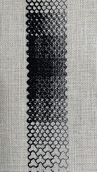
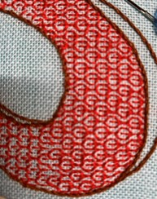 | WI House  17 Couch Lane  Devizes SN10 1EB
TICKET PRICE: £28.50 – includes tea/coffee/biscuits
Non-members are also welcome.
CLOSING DATE: Monday 24th June 2024 (Unless fully booked)
ENQUIRIES TO: |  | Lesley Adam |  | Tel: 01225 704096
(no ticket sales) |  |  |  | Email: lpadam@gmail.com
Cheques will be banked once minimum numbers are reached. If a refund is due for any reason it will be sent accordingly.

