WHAT’S ON IN WILTSHIRE
Apr / May 2024
RESOLUTIONS WORKSHOP  Thursday 18th April  10.00am – 12.00pm  Closing date: 11th April |  |  |  |  |  | WI House  17 Couch Lane  Devizes SN10 1EB  £5.00
A workshop to explain how the resolution process works from start to finish and guide you through everything you need to know. (your WI can pay for you to attend)
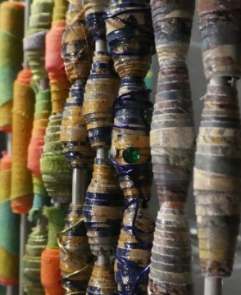 |  |  | BEAD MAKING WORKSHOP  Tuesday 30th April  10am – 1pm or  1.30-3.30pm  Closing Date: 16th April |  |  |  |  |  | WI House  17 Couch Lane  Devizes SN10 1EB  £18.00 per person
This workshop introduces you to the basic skills and will you show how to start off your bead making journey. All materials will be provided.
DADS ARMY: The Nation’s Favourite Comedy  Tuesday 7th May  2.00pm – 4.30pm  Closing date: 9th April |  |  |  |  |  | Southwick Village Hall  Frome Road  Southwick BA14 9QG  £25.00 |  |  |  | 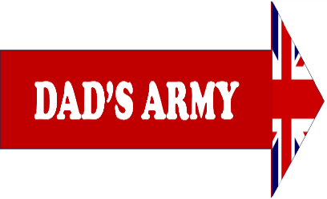
Charles Garland will talk about his time as Producer on this sitcom made in the 60s and 70s. Followed by afternoon tea.
 |  | Great Bedwyn Village Hall  Frog Lane, Great Bedwyn,  Marlborough SN8 3PD  £15.00 |  |  |  |  |  | FAST FASHION  Wednesday 15th May  7.00pm – 9.00pm  Closing date: 17th April
Victoria has a passion for finding beautiful clothes from second hand shops and jumble sales and is a firm believer that once you know the rules of what suits you best you really can shop anywhere.
WELLNESS DAY  Saturday 18th May  10.00am – 3.30pm  Closing date: 29th April |  |  |  | Bowerhill Village Hall  Halifax Road, Bowerhill  Melksham SN12 6SN  £28.00
A Wellness Day to give you some ideas and guidance on how to improve your well-being. There will be free activities including Yoga, Tai Chi; and talks by Colour by Design and on Feng Shui.
WI House, 17 Couch Lane  Devizes SN10 1EB | OFFICE 365 TRAINING  Thurs 23rd May & Thurs 20th June  10.00am – 12.00pm

