
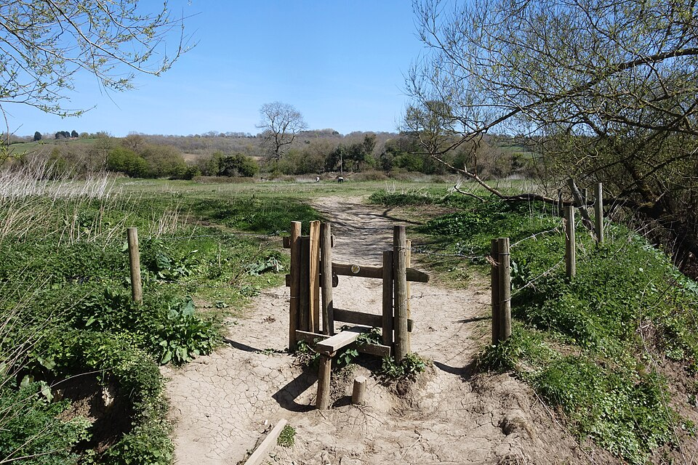  Attribution: Stile near Lacock by Des Blenkinsopp  Creative Commons Attribution-Share Alike 2.0 Generic license  Walking in Wiltshire | Friday 15th August  10.30am – 1.00pm  £5.00 per person
 | Meet at National Trust Car Park SN15 2RQ by 10.15am
Closing Date:
Weds 13th August
Join us this August as we explore the charming countryside around the historic village of Lacock! This scenic walk will cover approximately 5½ miles, taking in beautiful views, peaceful lanes, varying terrains and a taste of Wiltshire's rural charm.  Well-behaved dogs on leads are welcome to join the fun!  Meet at the National Trust car park, which is free for members or £5.00 per day for non-members. Everyone is welcome—members and non-members alike!  TryBooking: https://www.trybooking.com/uk/EZUX |  | 
The following details must be emailed/posted to admin@wiltshirewi.org.uk (unless using TryBooking):  WI Name, Contact Name & email address  Number of tickets Required  Attendee(s) Names  Total amount due  BACs Payments: (use ref: WW0725)  Refunds will only be given if the Federation cancels or if you cancel before the closing date |  |  | BACs payments:  Wiltshire Federation of WIs  Sort Code: 30 96 26  Account No: 79519268  Cheques payable to: Wiltshire Federation of WIs
and posted to:
WI House
17 Couch Lane
Devizes SN10 1EB
Charity No: 1197142
01380 739340

