FAQs and Useful Tips
Meeting the Adviser sessions Notes

The Membership Committee held two sessions on the 19th and 20th January, for any WI members to virtually meeting the WI Advisers. This is a collation of useful information and questions raised in the sessions.

Annual meeting guidance has been collated and disseminated separately.

Virtual Meetings
- Start small with virtual coffee mornings.
- Get members used to the technology before you start full meetings.
- There are useful tutorials available. Buckingham Federation of WIs have some fantastic tutorial videos https://www.bucksfwi.org.uk/library.html
- Buddy “tech savvy” members up with those who are unfamiliar with it.
- You don’t have to pay for zoom to trial it. Perhaps test it out on a 1-2-1 basis.

Online Banking
- A few questions were raised about online banking. This is possible to do virtually, some banks allow for a two-step online verification.
- Email trails approve spend is also sufficient for audit purposes.

Collecting Membership Fees
- Encourage members to use bank transfers where possible.
- Use cheques.
- Arrange a collection/ drop off time where social distancing can be observed.

Annual Reports and Budgets
We encourage WIs to report on the past year. This is useful for future records and as a record of the WIs history.

We also encourage committees to put together a budget for next year. If you have been unable to meet, propose ideas for how funds will be spent, for the benefit of all members, when meetings are permitted.

My WI
My WI is a very useful resource; it has lots of useful information and reference documents available. https://mywi.thewi.org.uk/

Wiltshire WI Website
We post useful information on our new website. https://www.wiltshirewi.org.uk/

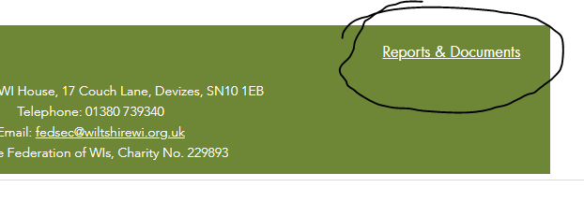
You can also access Wilts Fed event information, which is stored in a password-protected area. Email Ruth to gain access to this resource. ruthdavies@wiltshirewi.org.uk

WI Adviser Visits
Each WI has an assigned WI adviser, however due to the current lockdown; this allows our advisors to, potentially, provide broader geographical coverage for virtual meetings. If you would like one of us to attend a virtual meeting, we can try to accommodate this.

Wiltshire WI Magazine
We are aware that many members have paid for a years’ worth of magazines and have not received them. Members will not miss out on what they are owed. This will be worked out by the office when we are back to “normal”.

Finance Questions answered
- If a member does not re-join in April, and then choose to join later in the year, they cannot claim the pro-rata membership rates. They must have left for a year to benefit from this. (This has recently been decreased from 10 years!)

Sharing good news
If you have had a successful transition to virtual meetings, or are putting “meetings in a bag” together- we would love to hear from you. We are keen to share inspirational news from WIs across Wiltshire.

We encourage the writing of blog posts/ newsletter articles. Please email one of the advisors or fedsec@wiltshirewi.org.uk.

